**KISSlicer manual (sort off) by OrkusMG**

What you receive in KISSlicer64_orkusmg.zip is my profiles, Stephan’s test.py script that changes accelleration and square corner speed for different parts of a print (i.e. external walls have different accell than internal etc.). You will also find there model of my bed and Calibration Models (use ks_wizard.stl for flow/temperature/PreloadVE wizards).

Unpack everything wherever suits you and let’s go!

1. Download latest version of python for your operating system (install and forget): <https://www.python.org/downloads/>

This allows KISS to use test.py script. (Script file should be always located in your KISSlicer directory, right where it was when you unpacked everything)

1. To view the script you need some text editor that can read it. I recommend Sublime Text : <https://www.sublimetext.com/>

If you will not be happy with results you can edit below values:

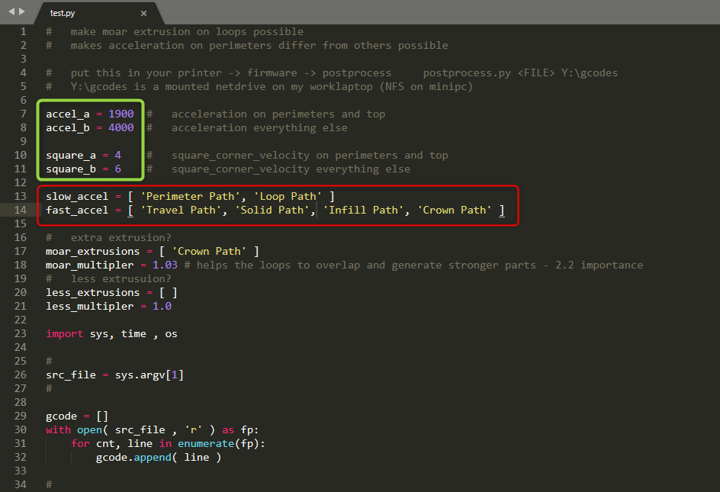

Bare in mind that accell here is 4000 – you should modify your printer.cfg to allow printer to go this fast (if you have afterburner, or 350 or bigger printer, you should consider to lower both values, but that’s entirely up to you and your print quality).

1. Once you have both installed and edited to your likings (although I encourage you to test default values), you need to create a folder on your drive i.e. D:\GCODES and from now on **this is the only place you are allowed to save your gcodes to**. Now go to this (picture below) location in KISS and make sure the last part contains exact path to your gcode folder – make sure there are no spaces in the name of this folder or any folder above it.

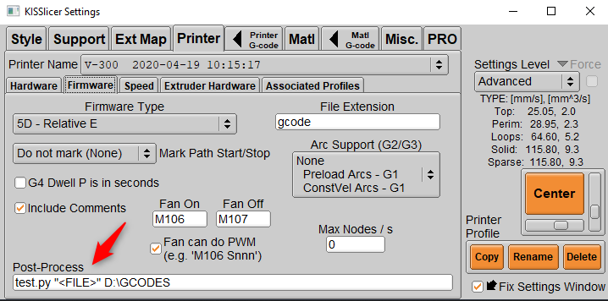

1. Your start and end gcodes are located here (most likely you can copy them from your old slicer, remember to change it before 1st print):

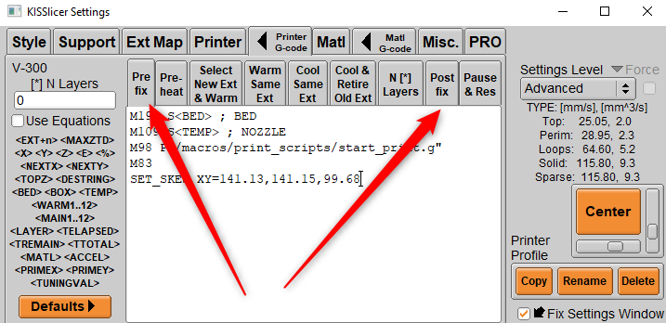

1. This is KISS’es original gcode for purge line (I encourage you to test it – made me stop using nozzle brush)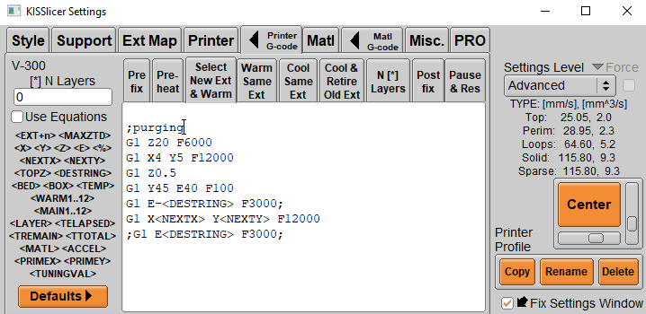
2. Select your Voron size on right hand top corner.

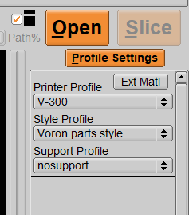

1. Now drop any stl to KISS and slice it, than save it to your newly created folder. Black window (similar to windows command line) should popup for a brief moment and disappear – this means that you KISS can see and use test.py script.
2. On a Style tab you will find some profiles. Those that I marked below are handy for Wizard (top menu of KISS) that will help you fine tune all settings, find the best printing temp for new fiament etc (this last is very handy as I practically changed printing temp for all filaments I thought I know). For printing my “go to” profile is “Voron parts style”.

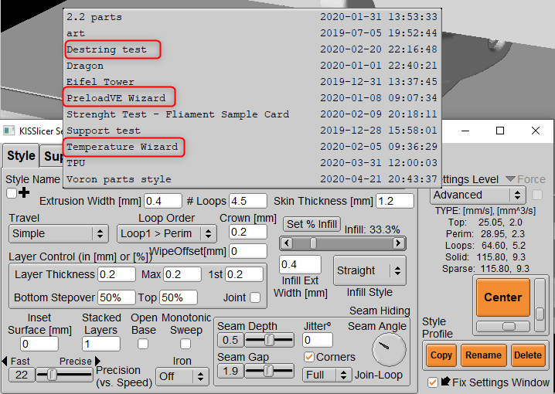

1. If you change any value in any of the profiles and close KISS it’s automatically saved, hence at least at the beginning use Copy button to create your own profile to mess around ;) KISS has excellent profile management, it’s very easy to create profiles and manage them.
2. Basic material tab functions:

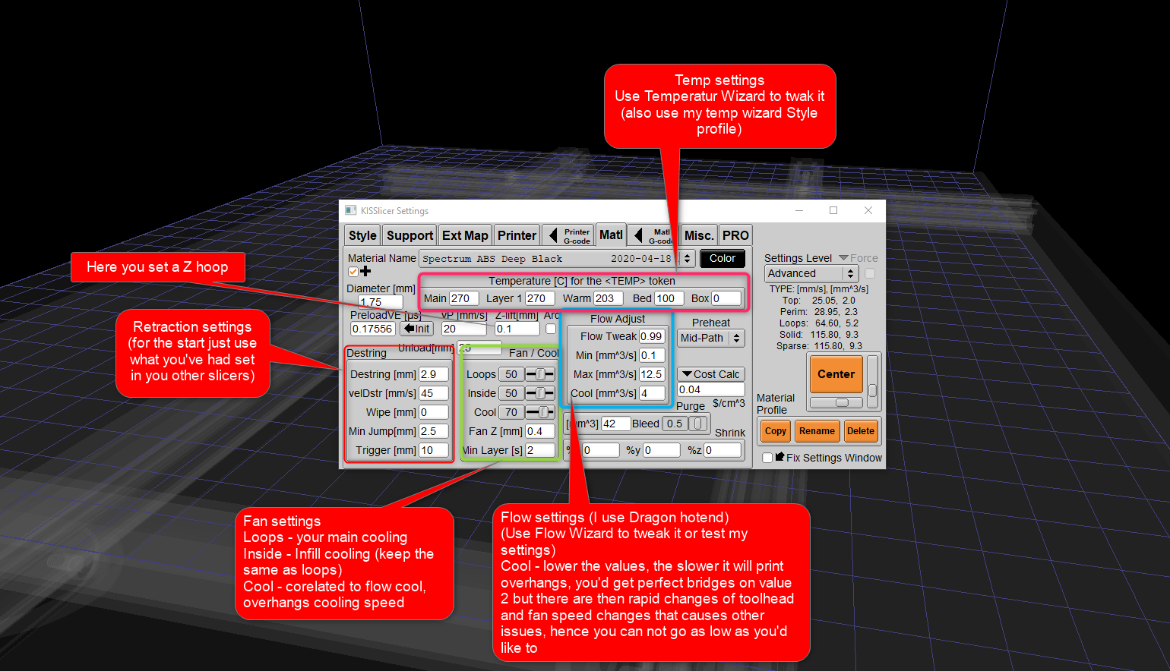

1. Basic Style functions:

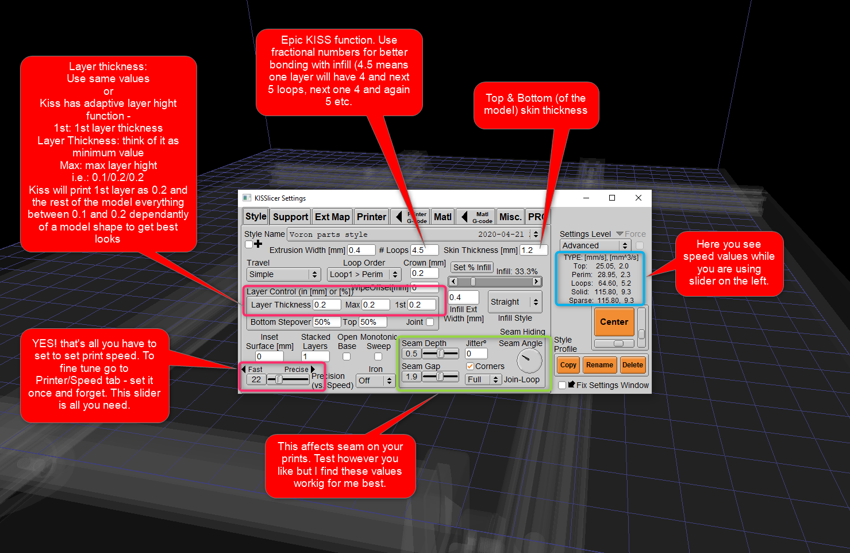

1. Before 1st print – Use Tunning Wizard

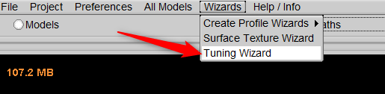

Example Wizard – Pick temperature – everything will change to yellow, this means that KISS is in wizard mode and it will use only specific slicing functions related to particular Wizard.

Set your min and max temp written on the filament, use the attached ks_wizard.stl and use my Temperature Wizard style on Style TAB. Hit slice and save gcode to your folder (and print it). Do not close wizard as you’ll have to enter a value in mm as described below

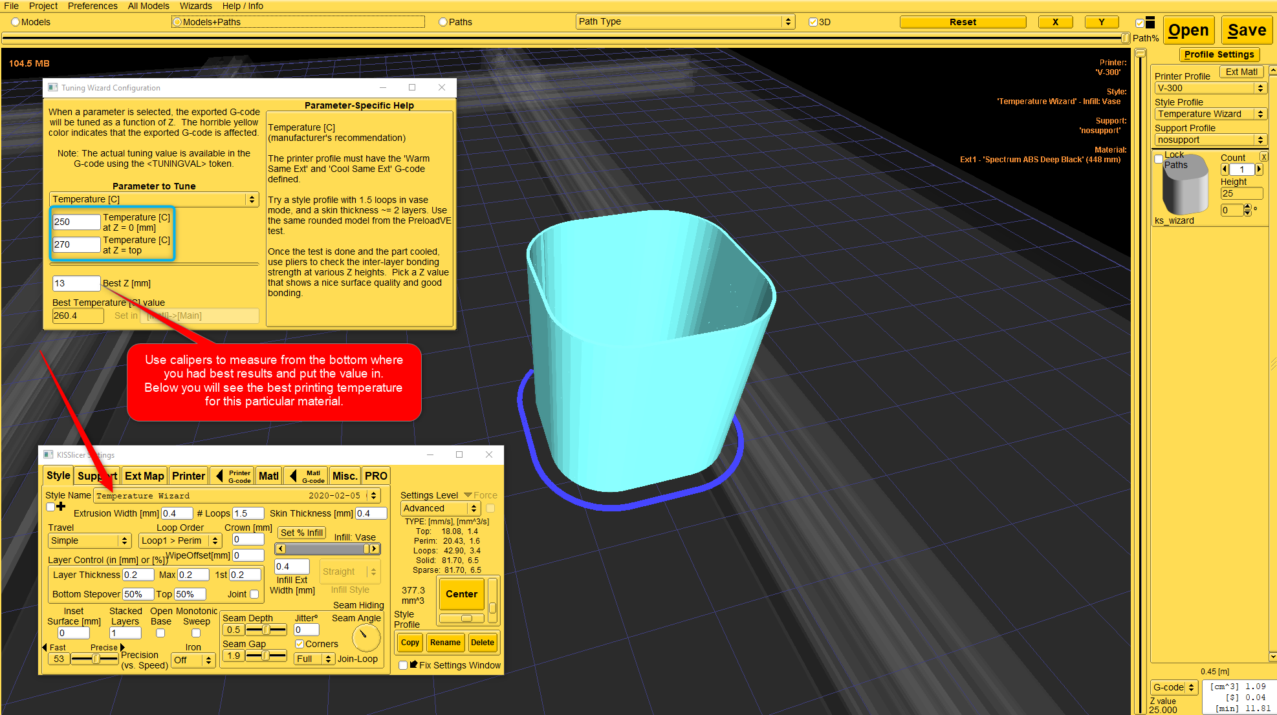

To exit wizard select None on it’s drop down menu – yes, I know… ☺

Experiment with other wizards, have fun and remember – what works for me, might not work for you but my general setting should give you nice results from the start. If you are not happy with results remember to

